Diocese of Wheeling-Charleston
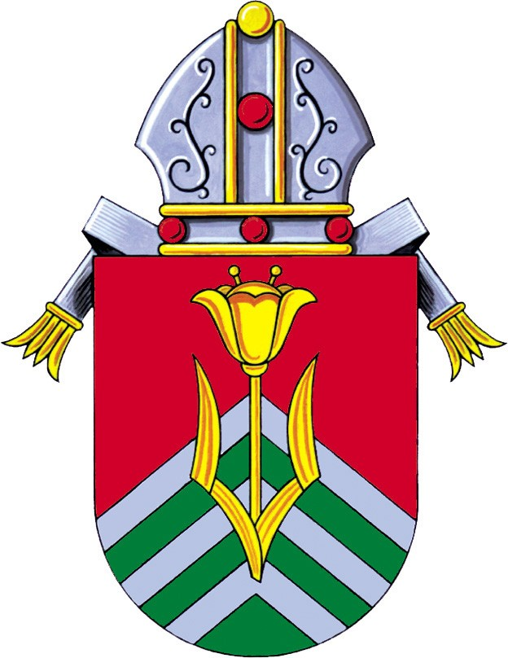
Catechist Certification
For Religion Teachers/Catechists in Catholic Schools

Four Levels:

- Practitioner Level
- Religion teachers in Catholic Schools must complete the Practitioner Level (5 modules – see below) within 4 years

- Professional Level I
- Religion teachers in Catholic Schools must complete the Professional Level I (4 modules – see below) within 4 years of completing the Practitioner Level

- Professional Level II
- Religion teachers in Catholic Schools must complete the Professional Level II (4 modules – see below) within 4 years of completing the Professional Level I

- Advanced/Masters Level
- Religion teachers in Catholic Schools with a B.A. in Theology or Religious Studies from accredited universities will automatically receive certification at the Advanced Level. Religion teachers in Catholic Schools with a M.A. in Theology or Religious Studies from accredited universities will automatically receive certification at the Masters Level.

Note: Some modules or requirements may be waived or added depending on experience and/or education.

Requirements for Practitioner Level:

Complete the 5 modules below from VLCFF online courses through the University of Dayton:
Note: Pre-school teachers need to complete only the 3 courses below that are marked with an asterisk

Theology Modules: Survey of Catholic Doctrine or Catholic Beliefs *
Sacraments
Introduction to Scripture or Bible Basics *
Images of Jesus
Formation: Introduction to Prayer or Praying with Children *

Requirements for Professional Level I:

Complete the requirements for Practitioner Level and the 4 modules below from VLCFF online courses
through the University of Dayton:

Theology Modules: Introduction to Christian Morality or Conscience
Survey of Catholic Social Teaching
Methodology: Faith & Human Development
Introduction to Catechesis

Requirements for Professional Level II:

Complete the requirements for Practitioner Level and Professional Development I and the 4 modules below
from VLCFF online courses through the University of Dayton::

Theology Modules: Church History I or II or The Second Vatican Council: An Overview
New Testament
Catholic Teaching on Chastity, Family Life, and Human Sexuality Education
Methodology: Theological Reflection: Key to Connecting Faith and Life

University of Dayton
The Virtual Learning Community for Faith Formation (VLCFF)
The Virtual Learning Community for Faith Formation (VLCFF) is coordinated and sponsored by the Institute for Pastoral Initiatives (IPI) at the University of Dayton, a Catholic Marianist Institution.
VLCFF is a growing initiative to offer adult religious education and faith formation anytime and anywhere via the internet. The goal is to support the church's professional ministry of religious education and faith formation in cyberspace.
Why is the VLCFF important for diocesan ministry as an alternative to traditional offerings?
- Time: adult religious education / faith formation courses are not offered at a convenient time for more and more of our adults living complex time demanding lives.
- Distance: it is too far for teachers/ catechists to drive to a course offering. Or, too few people sign up for a diocesan
- Availability: courses are not offered when a catechist or parishioner is available.
What is VLCFF Diocesan Partnership?
- Partnership offers dioceses an opportunity to join with others to do what they cannot necessarily do alone, that is, offer quality catechist and faith formation courses via distance learning. By partnering a diocese joins the Institute for Pastoral Initiatives and other partnering dioceses sharing resources and expertise to have more opportunities for catechist and faith formation. The Diocese of Wheeling-Charleston is a partnering diocese.

Course Fees / Payment Policy
- VLCFF courses are generally 5 weeks in duration. For individuals who live in a VLCFF partnering diocese, courses cost $40.00 each ($20 is paid by DWC and $20 by the school/teacher). For individuals who live in a non-partnering diocese, courses cost $90.00 each. See partnership information for a list of VLCFF partners.

- Book Requirements
Some courses require books. To determine if the course you are interested in has a book requirement, go to the "Courses" link on the left side of your screen. Find the course you are interested in among the list of courses provided. Click on the course name, then click the "Click for Course Details" link. This will show you the books you will need if any. Upon registering, you will receive an e-mail message telling you where the books can be purchased.

- Payment Policy
Payment is due before the course begins. You may pay by credit card on our secure site or you can send a check or money order, payable to the Institute for Pastoral Initiatives, to:
- Institute for Pastoral Initiatives/VLCFF
300 College Park Drive
Dayton, OH 45469-0314

- Please write your course number on your check, and if you are an organization paying for an individual write the individual’s name on the check.

- After a course begins there is no refund. Only if you cancel your course registration by midnight on the Friday before the course begins will you be issued a refund or credit to your account.
To Register and Begin Coursework
- Go to vlc.udayton.edu to register and begin coursework. Be sure to indicate you are from the Diocese of Wheeling-Charleston in order to ensure that you receive the discounted rate.

(Reviewed 2019)

