Unit Planner
Name of Teacher: Ms. Hannah Brown |  | Grade Level: 6
Subject Area: Reading |  | Cross Curricular Opportunities: Religion-Mrs. Bee
Unit Title: Tuck Everlasting |  | Estimated Duration of Unit: 2.5 weeks
Overview of Unit: Whole Group Instruction- Individual Instruction-Small Group Cooperative Learning
Forms of Text (non- fiction/fiction): fantasy literature |  | Teaching Strategies: Vocabulary, Summarizing Skills, Figurative Language, Graphic Organizers, Technology skills
Assessment (authentic/published - summative/formative): group discussion, question sets, presentation
 | Description of Activity |  | Resources | Date of Completion
 | Distribute Tuck Everlasting Packet and Books. Explain students will need to read book and complete questions as homework and complete by given timeline in the packet given to them. (attached) |  | Tuck Everlasting Packet, Book | Day 1
 | Students will split off into their literature circle groups and discuss the main characters in the story. Each student will then get an iPad and log onto Padlet (link attached). The Tuck Everlasting Padlet is where we will come together as a whole group for discussions and I will be able to check their understanding throughout.  https://padlet.com/hbrown49/j2ia7ru9fai8 |  | iPads, Character Notes Sheet (in packet), Tuck Everlasting book | Day 2
 | Students’ will split into their literature groups. Each group will have four different chapters to discuss within themselves (for example: Group 1 will have chapters 1-4, group 2 will have chapters 5-8, etc.). They will have 10 min to talk over the chapters given to them. Once they have discusses among themselves a person from each group will present the information they found most important in the group, if they had any lingering questions, and discuss the questions given to them. (Formally assess students. Make notes to whether they understood their chapters or not.) |  | Chapter Question Sets | Day 3 and 4
 | As a whole group we will discuss the plot: 1. Why is it important for Winnie to Understand why she must keep the Tuck’s secret? 2. How does Winnie’s life change through her experiences thus far? Add information discussed to Padlet.  Discuss Setting/Place and Time: 1. Why is it that no road goes directly through the woods important? 2. What do you think the author means when she writes that the road’s “sense of easiness dissolved” at the edge of the wood? 3. What descriptive words does the author use to describe the two different environments of the Foster’s and Tuck’s homes? Time, Place, and Surround details. In groups students will comment on the Padlet to insert the information the come up with. They can also add the bubbles if they feel it is needed. |  | Ipads | Day 4 and 5
 | As a whole group, briefly discuss metaphors. Give examples, and make sure students’ do not have any questions.  Discuss symbolism of the Ferris Wheel and what metaphors are using during to explanation of the Ferris Wheel–complete worksheet on their own.  Discuss tomorrows upcoming assignment – what programs can be used to create a news article. (Microsoft word, Infographic) |  | Ferris Wheel Worksheet | Day 6
 | - Questions Set 1 – DUE  News reporting activity- student will be given a paper with names of different characters. They will have to act as if they were the news reporter who just found out about a mysterious family that never seems to age. The editor wants them to find out if the rumor is true. The student will think of two questions to ask each of them and fill in the sheet of paper. Once they have come up with the questions they will create a news article containing at least two of the characters and the questions they used to interview them.  *Show students examples of new articles  *Review rubric |  | Computers, New Reporter Sheet, Rubric | Day 7 and 8
 | Students will work together in their groups to complete a graphic organizer/response sheet comparing and contrasting the Tuck’s and the Foster’s. Once completed we will come together as a whole group and discuss each family then students will add this to our “Padlet” by using the iPads. |  | Compare and Contrast Worksheet - Ipads | Day 9
 | Students’ will split into their literature groups. Each group will have three to four different chapters to discuss within themselves (for example: Group 1 will have chapters 14-16, group 2 will have chapters 17-19, etc.). They will have 15-20 min to talk over the chapters given to them. Once they have discusses among themselves a person from each group will present the information they found most important in the group, if they had any lingering questions, and discuss the questions given to them. Groups not presenting will take notes on the chapters that was not given to them for discussion. (Formally assess students. Make notes to whether they understood their chapters or not.) May take up to two days |  | Question sets | Day 10 and 11
 | Review Day. Go back over information discussed on the Padlet and notes taken throughout the book. |  | Padlet information, Questions and notes taken throughout | Day 12
 | - Extra Credit Due  - Question Set #2 Due  Final Book Test |  |  | Day 13

Standards:
ELA.6.R.C2.4 | Students will determine the meaning of words and phrases as they are used in an informational text, including figurative, connotative and technical meanings.
ELA.6.R.C3.1 | Students will compare and contrast the experience of reading a story, drama or poem to listening to or viewing an audio, video or live version of the literary text, including contrasting what they "see" and "hear" when reading the text to what they perceive when they listen or watch.
ELA.6.R.C4.1 | Students will, by the end of the year, read and comprehend literature, including stories, dramas and poems, in the grades 6–8 text complexity band proficiently, with scaffolding as needed at the high end of the range.
ELA.6.R.C3.3 | Students will integrate information presented in different media or formats (e.g., visually, quantitatively) as well as in words to develop a coherent understanding of a topic or issue.

Reflection:
Overall the unit went really well. When I was searching for something technology based to keep my students engaged, I ran across an app called “Padlet”. This was an awesome asset to the unit as a whole. They were able to communicate in small groups then come together as a whole and see things visually. It was also a nice review for the students. We were able to go back and look a the work we had completed throughout the past few weeks.
One thing I would change would be to shorten the timeline of reading of the book. It was an easier book for most students’. So when others were ready to move on we still have to wait a couple days for others to catch up in the book.

Unit Attachments:

http://www.sps186.org/downloads/basic/47950/Tuck_Everlasting_E.C..pdf (online resource)

Literature Circle Groups:
- Aidan, Landon, Maura
- Haedyn, Bella, Carter
- Elijah, Lindsay, Brier
- Daniel, Perry, Declan

Images:
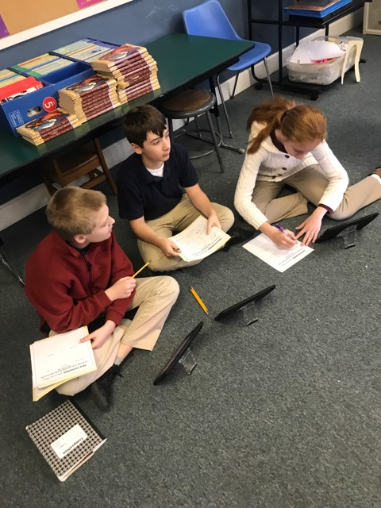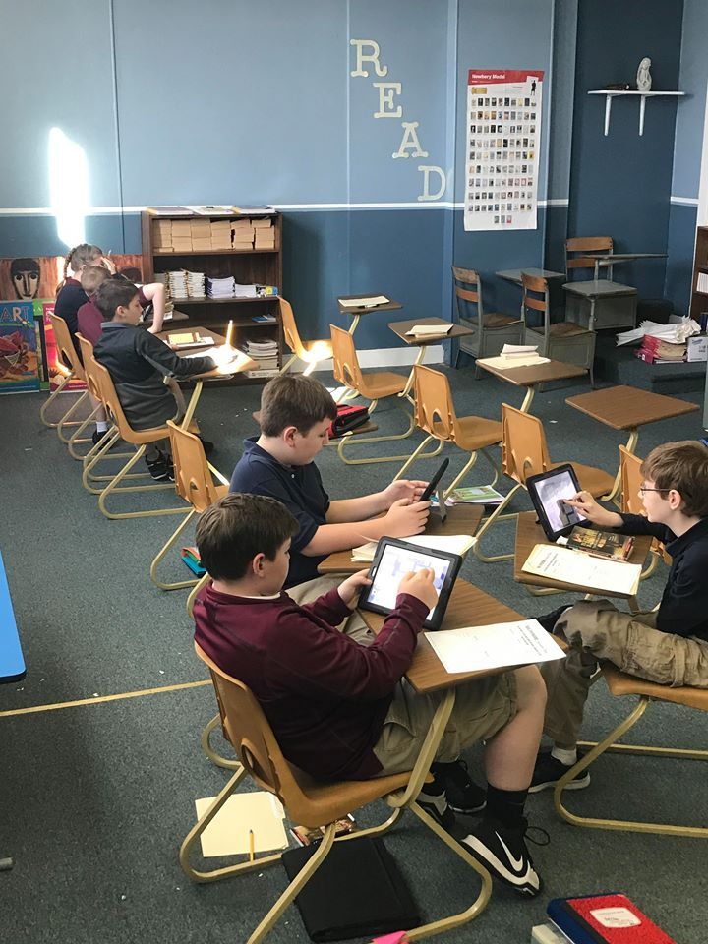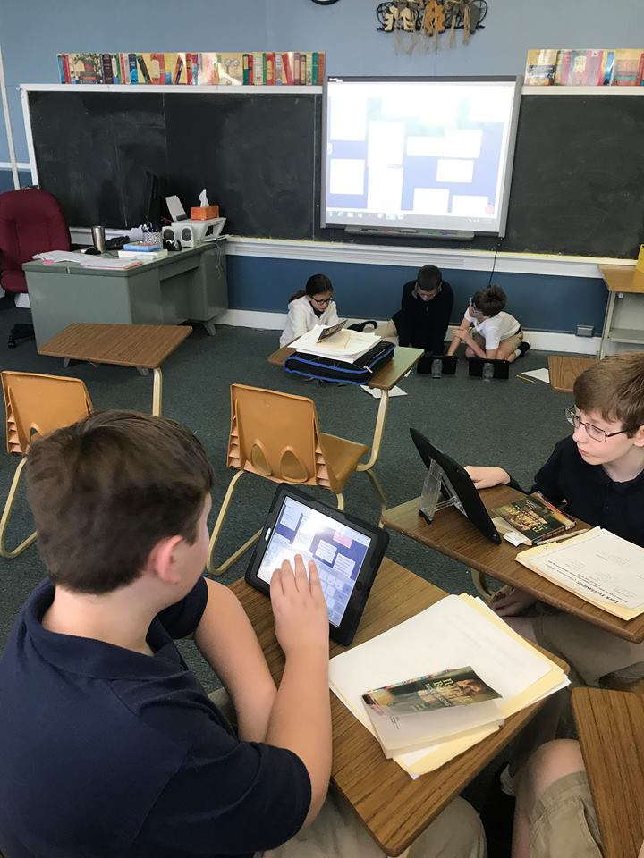

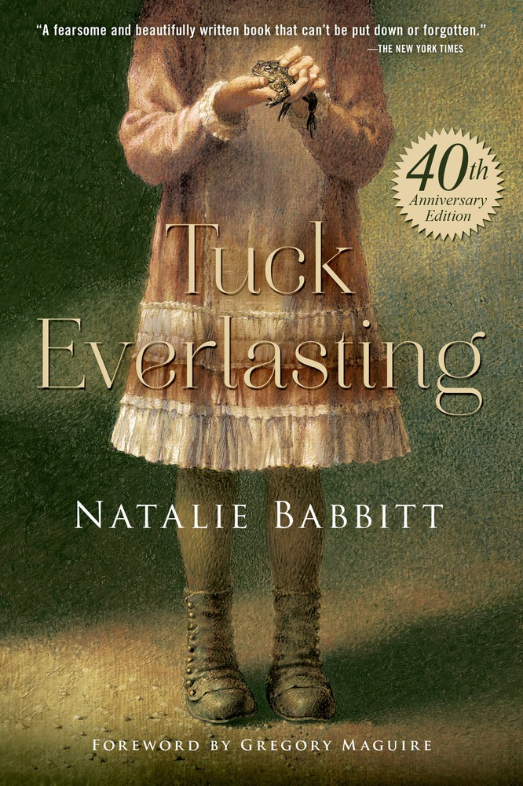

Tuck Everlasting Packet
6th Grade Novel Study
Fairmont Catholic School

Tuck Everlasting Outline

Chapters: | Read By: | Questions:
Prologue - 13 | Monday, April 23rd | Monday, April 30th
14-25 | Wednesday, May 2nd | Wednesday, May 9th
Extra Credit | Due on Final Book Test Day

Note: Student should read book and complete questions at home. We will not be working on this in class unless you have extra time.

Tuck Everlasting Questions- Set 1
Questions must be typed. Minimum word count 400 for each set. Your answers must be completed in full sentences. If there is more than one question for each number you must answer both in more than one sentence.

Chapter 1:
- How does the author’s use of language help you to understand the setting?
- Why aren’t the Fosters curious about the wood? If you were Winnie, do you think you might have wanted to explore the wood? Why or why not?
Chapter 2:
- Why does Angus Tuck consider his dream about heaven a “good dream”?
- Why do you think Mae Tuck doesn’t care about her appearance anymore?
Chapter 3:
- What do you think Winnie’s life is like? How does it compare to your life?
- Why does Winnie throw stones at the toad? What emotion do you think she is feeling?
- Why does Winnie tell the toad she wants to run away?
Chapter 4:
- What is your first impression of the main in the yellow suit? Does the author give you any clues about his character?
- Where do you think the music that Winnie’s grandmother hears comes from?
Chapter 5:
- What do you think Jesse is thinking when he tries to prevent Winnie from drinking the spring water?
- What does Mae mean when she says, “The worse is happening at last”?

Chapter 6:
- Why do the Tucks kidnap Winnie? What do you think you would have done in Winnie’s place?
- Why does Winnie feel reassured when she hears the music box?

Chapter 7:
- How had the Tucks figured out they were going to live forever?
- Why do you think the man in the yellow suit is following Winnie and the Tucks?
Chapter 8:
- Why does Winnie begin to feel happy about being with the tucks?
- The man in the yellow suit overhears the Tucks’ story. What do you think he might be planning?
Chapter 9
- It takes many hours for Winnie, Mae, Jesse, and Miles to reach the tucks’ home. Why do you think they live in such a hard-to reach place?
- Why do you think Angus Tuck is so happy to meet Winnie?
Chapter 10:
- Do you think Mae thinks her life is blessed or cursed?
- Why is Winnie so amazed at the inside of the Tucks’ home?
Chapter 11:
- Why does Winnie suddenly want to go home?
Chapter 12:
- Why does Angus Tuck take Winnie to the pond to talk to her?
- How is the movement of the pond water meaningful to their conversation about the life cycle?
Chapter 13:
- Why do you think the man in the yellow suit goes to the Fosters instead of the police?

Tuck Everlasting Questions- Set 2
Chapter 14:
- Why does Winnie go back and forth, first liking the disorder of the Tuck’s lifestyle, then longing for her regular bedtime routine?
- How do the Tuck’s make Winnie feel better?
- As Winnie tries to fall asleep, she can’t decide whether or not to believe the Tuck’s story. Would you have believed it? Why or why not?
Chapter 15:
- Why do you think the man in the yellow suit wants to trade his knowledge of Winnie’s whereabouts for the Foster’s wood?
- What does the man in the yellow suit’s actions tell you about his character?
Chapter 16:
- Why is the constable surprised that the Fosters agree to sell the wood?
- Is the constable suspicious of the man in the yellow suit’s motives?

Chapter 17:
- How does swatting a mosquito make Winnie realize that dying is a natural part of the life cycle?
- Why does Winnie insist that Miles throw the fish back?
Chapter 18:
- Why do you think Miles conceals the reason that he and Winnie return without any fish?
- How have Winnie’s feelings for the Tucks changed? Do you think she has stronger feeling for some of the Tucks than others?
Chapter 19:
- Why does the man in the yellow suit see the Tucks as selfish?
- Mae Tuck hits the man over the head with the gun. Do you think she does the right thing? Does she have another option?
Chapter 20:
- Why does Winnie lie to the constable?
- Angus Tuck stares at the man in the yellow suit after Mae hits him. What do you think he is thinking about? Why does Winnie seem horrified at Angus Tuck’s reaction?

Chapter 21:
- Do you think the Fosters regret selling the wood?
- What makes Winnie’s family think she has changed?
Chapter 22:
- Why does Winnie volunteer to help rescue Mae?
- Do you think Jesse should have given Winnie the spring water? Why or why not?
Chapter 23:
- Why does being disheveled make Winnie’s mother and grandmother more interesting?
- Why does Winnie feel so good and right about what she is about to do?
Chapter 24:
- How do you think Winnie feels helping Mae escape?
- Do you think Winnie does the right thing by freeing Maw? Why?
Chapter 25:
- How does Winnie’s reputation in the village change after she helps Mae?
- Why do you think Winnie saves the toad from the dog?
- What important decision does Winnie make when she pours the spring water on the toad?
Epilogue:
- How does the author connect Winnie and the Tucks at the end of the story?
- Why does Angus Tuck say, “Good girl,” when he sees Winnie’s grave?

Tuck Everlasting Final Test

Name: ______________

Character Descriptions
Write at least three characteristics about each given character.
- Winnie Foster

- Grandmother

- Angus Tuck

- Jesse Tuck

- Mae Tuck

- Man in the Yellow Suit

- Constable
Order of Events
Number the following events in the order they occurred in the story, from #1-#7.
____Mae escapes from the jailhouse
____The man in the yellow suit dies
____Winnie meets Jesse for the first time
____Winnie pours bottled spring water on the toad
____Miles puts the fish back in the water
____The man in the yellow suit tells the Fosters he knows how to get Winnie back
____Winnie thinks about running away into the woods.

Multiple Choice Questions
- Who is the Author of Tuck Everlasting?
- Natalie Babbitt
- B. J.K Rowling
- Garth Nix
- D. Shakespeare

- Who does Winnie always talk to at the start of the book?
- Her mother
- Her grandmother
- A toad
- A few boys in the town

- By the tree, who did she see?
- Miles Tuck
- Jesse Tuck
- Mae Tuck
- Mr. Tuck

- What calmed Winnie down after the Tucks took her away?
- The ride on the horse
- Jesse Tuck
- The music box
- Mae Tuck

- How many years ago did the Tucks find the magic spring?
- Eighty-seven
- Fifty-four
- Ten
- Thirty-two

- Who didn’t drink the magic water?
- Jesse Tuck
- The horse
- Miles Tuck
- The cat

- How did the Tucks prove to themselves that they wouldn’t ever change?
- Tuck shot himself with him shotgun
- They shot the horse
- Jesse jumped out of a tree from way up high
- They told Winnie to shoot them

- Who saw the Tucks take Winnie away?
- The mother
- A neighbor
- The man in the yellow suit
- The constable

- Where did Tuck take Winnie to tell her the whole story?
- A boat on the pond
- A treehouse
- The living room
- The front lawn

- What does Tuck wish?
- He wishes to live forever.
- He wishes he never drank the magic water.
- He wishes for a new house.
- He wishes he had been younger when he drank the magic water.

- Who helped the Tucks get Mae Tuck out of jail?
- The man in the yellow suit
- The toad
- Winnie
- Winnie’s father

Short Answer: Answer in complete sentences
- How do Winnie’s decisions affect the outcome of the book?
_________________________________________________________________________________________________________________________________________________________________________________________________________________________________________________________________________________________________________________

- Why is it important for Winnie to understand why she must keep the Tuck’s secret?
________________________________________________________________________________________________________________________________________________________________________________________________________________________________________________________________
- How does Winnie’s life change through her experiences?
________________________________________________________________________________________________________________________________________________________________________________________________________________________________________________________________

- What is good and what is bad about the prospect of eternal life?
_________________________________________________________________________________________________________________________________________________________________________________________________________________________________________________________________________________________________________________

- How does the wheel metaphor help you understand the life cycle? _________________________________________________________________________________________________________________________________________________________________________________________________________________________________________________________________________________________________________________

Essay Questions: Need to be at least two paragraphs each. Write on separate sheet of paper.

- . Do you agree with the decision Winnie makes at the end of the book? Why or why not? Why do you think she decided to take this route? Did you see it coming? (Opinion essay)

- If you were offered the option, would you drink from the spring and accept immortality? Why or why not? (Narrative essay)

Extra Credit
Make a pro/con list about immortality. What would be the best parts? What would be the drawbacks? Does the narrator of Tuck Everlasting seem to have an opinion about it? (Compare/Contrast essay)

