Diocese of Wheeling-Charleston
CASE Unit Planner
Name of Teacher: Lisa Wingett |  |  | Grade Level: 3rd
Subject Area: Reading Language Arts |  |  | Cross Curricular Opportunities: Science and Math
Unit Title: Tops and Bottoms |  |  | Estimated Duration of Unit :  About 8 days
Overview of Unit: Students will understand that plants have different parts: roots, stems, leaves, seeds, flowers, etc. All of the activities are based upon the children’s book Tops and Bottoms by Janet Stevens.
Forms of Text (Fiction)  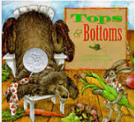 |  |  | Teaching Strategies: Direct Instruction, Concept Development through Brainstorming, Problem-Based Learning, Think-Pair Share Literature circles, Discussions, Projects, Read-aloud, Cooperative groups, Technological skills, Hands-on activities, Critical thinking approach, and Vocabulary enrichment
Catholic Identity Connections: Being a hard worker is important
Assessment (authentic/published - summative/formative): Formative throughout the Unit
Standard Number | Standards | Description of Activity |  | Resources | Date of Completion
ELA.3.R.C1.1 | ask and answer questions to demonstrate understanding of a literary text, referring explicitly to the text as the basis for the answers. | Students will read “Tops and Bottoms” and be able to answer questions to demonstrate understanding of text, referring explicitly to the text as the basis for their answer. Refer to details and examples in the text when explaining what the text says and when drawing inferences from the text. |  | Picture Book-Tops and Bottoms by Janet Stevens  Formative Assessment:  Comprehension Review on Quizlet https://quizlet.com/67521208/tops-and-bottoms-comprehension-review-flash-cards/ | Day 1
ELA.3.R.C1.3 | describe characters in a literary story (e.g., their traits, motivations, or feelings) and explain how their actions contribute to the sequence of events. | Create a character map.  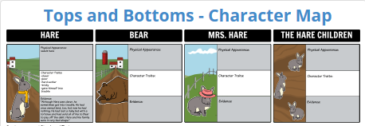  Students will describe characters in the story (e.g., their traits, motivations, or feeling) and explain how their actions contribute to the sequence of events. Describe in depth character, setting, or events in the story, drawing specific details in the text. (e.g., a characters thoughts, words, or actions). |  | Picture Book- Tops and Bottoms  Formative Assessment/Discussion  Character Map on http://www.storyboardthat.com/teacher-guide/tops-and-bottoms-by-janet-stevens  and character trait quiz. | Day 2
 | determine the meaning of words and phrases as they are used in a literary text, distinguishing literal from nonliteral language. | Students will determine or clarify the meaning of unknown and multiple-meaning words or phrases.  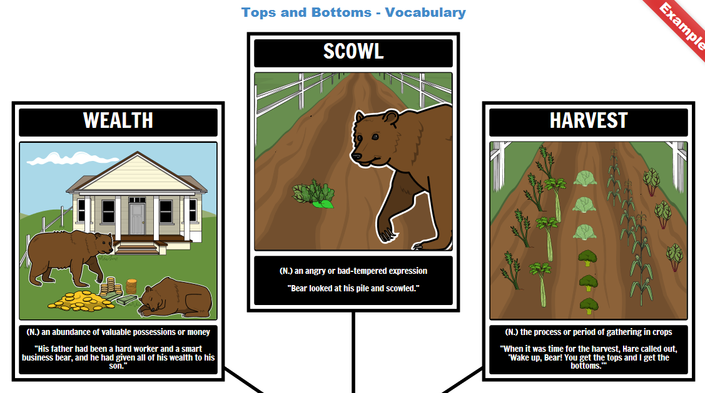  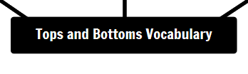 |  | Picture book, Vocabulary list with definitions, Vocabulary practice page, Vocabulary quiz, and vocabulary crossword puzzle.  http://www.storyboardthat.com/teacher-guide/tops-and-bottoms-by-janet-stevens  Vocabulary Quiz  Formative Assessment-Exit Slip | Day 3
ELA.3.R.C3.5 | compare and contrast the most important points and key details presented in two informational texts on the same topic. | Students will distinguish their own point of view from that of the narrator or those of the characters. Compare and contrast the point of view from which different stories are narrated, including the difference between first and third person narrations.  The students will also compare/contrast Bear and Hare in the story.  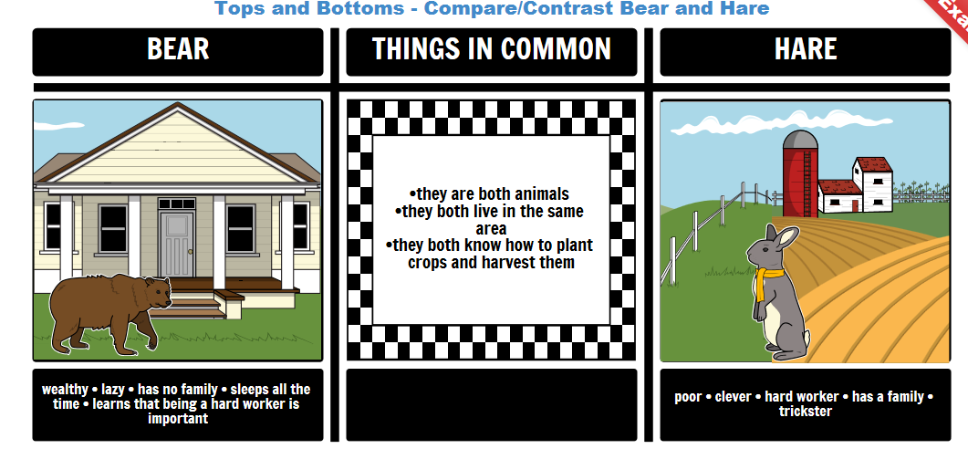 |  | Tops and Bottoms Venn Diagram, Tops and Bottoms compare and contrast writing activity http://www.storyboardthat.com/teacher-guide/tops-and-bottoms-by-janet-stevens | Day 4
SC.O.3.3.07 | explain a simple problem and identify a specific solution describing the use of tools and/or materials to solve the problem or to complete e task. | STEM Activity: Pairs of students will design a basket to hold vegetables that you make with a lid that closes to keep Bear out of the basket. The basket must hold vegetables students make from the story and measure 2 inches by 3 inches and the basket must be less than 8 inches wide and 4 inches tall. Five vegetables must be labeled. Baskets must be decorated according to the story and include “Bear…. keep out!” sign.  Students will present their design to the class. |  | Construction paper, glue, hole punch, brass fasteners, crayons, lids, straws, staples, cardboard, and scissors.  Rubric for Assessment | Day 5
C.O.3.2.02 | observe, measure and record changes in living things (e.g., growth and development, or variations within species). | - The class will plant some soda bottle carrots.  Activity:  Soda Bottle Carrots: A Very Small Kitchen Garden  Cut the top off of a three-liter soda bottle, fill it with soil, and plant some carrot seeds in it. The soda bottle carrots slide out of the planter.  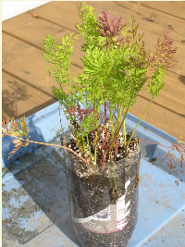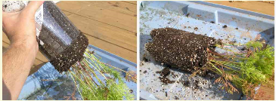  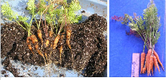A handful of 3-to 4 inch soda bottle carrots fresh from the soil  - Students will draw the different parts of a plant: roots, stems, leaves, seeds, flowers, etc. |  | Internet site:  http://www.smallkitchengarden.net/small-kitchen-garden/soda-bottle-carrots-a-very-small-kitchen-garden | Day 6
SC.O.3.2.01 | identify the structures of living things, including their systems and explain their functions. | Display a variety of plants. You may use pictures, too. Discuss the different plant parts (roots, stems, flowers, seeds, and fruit) and where they grow on the plant in relation to tops, bottoms, or middle. Show the examples of the variety of foods and ask students to identify the food sources on each plant, and if it grows on the top, middle, or bottom of the plant. |  | Plants or pictures of plants | Day 7
ELA.3.W.C9.2 | write informative/explanatory texts to examine a topic and convey ideas and information clearly | Informational Writing Activity  Students will use the 4-Square Graphic Organizer. The topic sentence is:  It is a marvel that so much in life that matters involves soil! |  | Rubric for Assessment | Day 8
Teaching Strategies Checklist
Writing
x | Paragraph
 | Essay (narratives, fairy tales, realistic fiction)
x | Summary
 | Research
x | Detailed answers (text supported)
x | Notes (note taking skills, outlines)
x | Complete sentences
Reading
x | Informational text
x | Reading Level -3.2
 | Complex literature
x | Speaking
x | Listening
x | Varied strategies and instructional methods
x | Critical thinking in whole class discussion
x | Student led activities
 | common core standards (literature circles)
Technology
x | Smart board
x | Computers
 | iPads
 | PowerPoint, Elmo etc.
Differentiated Instruction
x | Used multiple resources
x | Domain Vocabulary
x | Cross-Curricular
x | Collaborative engagement (meaningful feedback)
x | Higher level learning and teaching
Assessment
x | Project based
x | Writing prompt
 | Portfolio
x | Observation
x | Quiz
x | Technology based
x | Test
 | Student created test
x | Presentation
 | Journal
x | Think, pair, share
x | Summary
x | Oral questioning
 | Analogy
 | PowerPoint, or movie maker
Authenticity
x | Various activities
x | Inquiry, research and evidence
x | Evidence of time management and planning
x | Problem solving strategies
Summary of unit upon completion: Students will understand details in the story, draw inferences from the text, describe the characters in the text, clarify word meanings in the story, and identify the food sources on plants, and if it grows on the top, middle, or bottom of the plant.

