Step 1: Go to https://sophiainstituteforteachers.org/ and create a free account. Be sure that the email and password are something that you can share with your staff. Please note: there are only enough codes generated for each school to purchase the course for free ONCE and only ONCE, so please create only one account, “purchase” the course only once and allow your entire staff access to that one account.

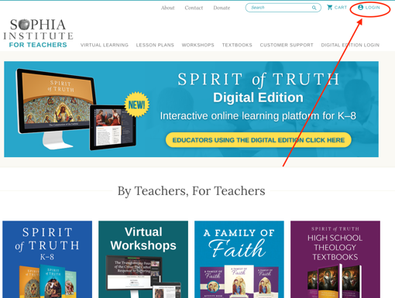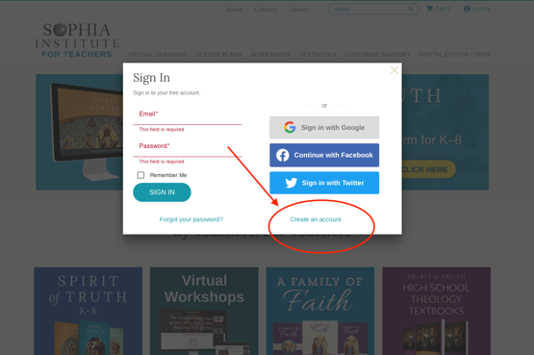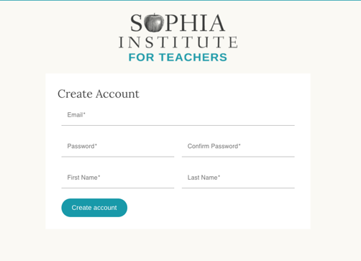

Step 2: Put The Sacraments and Discipleship in your cart. You can find the course by going to this link: https://sophiainstituteforteachers.org/workshops/virtual/the-sacraments-and-christian-discipleship

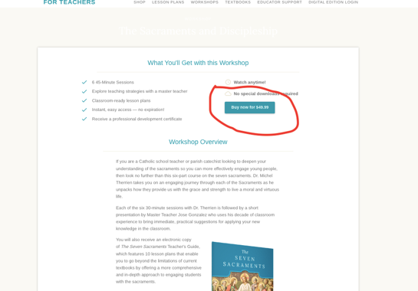

Step 3: At checkout, enter the following promo code: sacdisc100
(only use this code ONCE!))
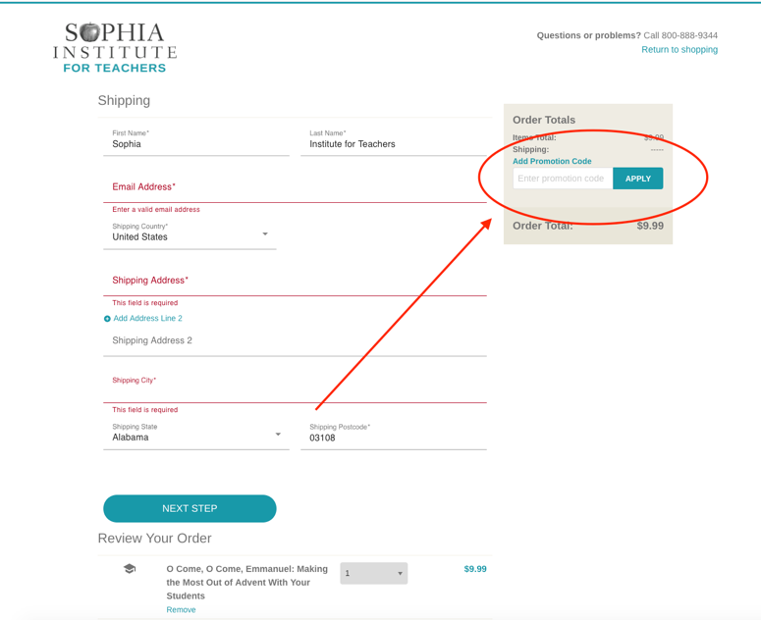

Step 4: After you complete checkout; your products can be accessed from your dashboard. When you click on “Dashboard” you will get a menu that appears on your right. Your purchased course will be in “Workshops”.
