Diocese of Wheeling-Charleston
Unit Planner (MS & HS Word Doc)
Name of Teacher: Kristen Malinowski |  | Grade Level: 6th-7th
Subject Area: Religion |  | Cross Curricular Opportunities:  English, Writing, and Religion
Unit Title: the Polar Express |  | Estimated Duration of Unit: 2 weeks
Overview of Unit: Throughout this unit, we will be establishing connections of religious context to the popular Christmas movie, the Polar Express. The class will read the story, compare it to the movie, and determine how God is mentioned and was present.
Forms of Text (non fiction/fiction): Fiction |  | Teaching Strategies: journals, response log, picture-book, discussion, drama, project-based
Catholic Identity Connections: Faith-Belief in a God we have not seen
Assessment (authentic/published - summative/formative): Formative
Standards Addressed
Standard Number | Standards
RLA.0.5.1.10 | compare and contrast text connections to self, to other texts and to world cultures in literary and informational  texts.
RLA.0.5.1.11 | identify literary techniques used to interpret literature (e.g., compare/contrast or cause/effect)
RLA.0.5.3.2 | compare and contrast personal experiences to oral/visual information
RLA.0.5.3.2 | listen and respond to different literary forms and speakers (e.g. summarize and paraphrase to confirm understanding, recount personal experiences, listen to information and exhibit comprehension, provide reasons in support of opinions, respond to others’ ideas).
CCSS.ELA-Literacy.W.6.4 | produce clear and coherent writing in which the development, organization, and style are appropriate to task, purpose, and audience.
Description of Activity |  | Resources | Date of Completion
Students will read the Polar Express prior to completing literature circle questions. You can find questions on the internet resource.  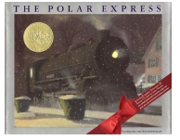 |  | Polar Express text  http://www.cape.k12.mo.us/blanchard/hicks/reading%20Pages/Polar%20Express%20Docs/Misc/Polar%20Express%20Questions.pdf | Day 1
Students will complete literature circle activities. Activities include questions from the text, expressing empathy, and rewriting parts of the story. |  | Literature Circle Packet  You can find some good literature circle information and blackline masters at this website.  http://www.teachingoasis.com/Literature%20Circles%20Sheets.pdf | Day 2  Day 3  Day 4  Day 5
Students will present a Reader’s Theater for K-1.  The Polar Express by Chris Van Allsburghttp://teachers.net/lessons/posts/3856.html  Readers’ Theater Script  Reader 1 On Christmas Eve, many years ago, I lay quietly in my bed. I did not rustle the sheets. I breathed slowly and silently. I was listening for a sound-a sound a friend had told me I’d never hear-ringing bells of Santa’s sleigh.  Reader 2 There’s no Santa  Reader 3 my friend insisted, but I knew he was wrong. Late that night I did hear the sounds, though not of ringing bells. From outside came the sounds of hissing steam and squeaking metal. I looked through my window and saw a train standing perfectly still in from of my house.  Reader 5 It was wrapped in an apron of steam. Snowflakes fell lightly around it. A conductor stood at the open door of one of the cars. He took large pocket watch from his vest, then looked up at my window. I put on my slippers and robe. I tiptoed downstairs and out the door.  Reader 4 All aboard  Reader 3 the conductor cried out. I ran up to him.  Reader 4 Well, are you coming?  Reader 3 Where?  Reader 4 Why to the North Pole of course. This is the Polar Express.  Reader 3 I took his outstretched hand and he pulled me aboard.  Reader 5 The train was filled with other children, all in their pajamas and nightgowns. We sang Christmas carols and ate candies with nougat centers as white as snow. We drank hot cocoa as thick and rich as melted chocolate bars. Outside the lights of towns and villages flickered in the distance as the Polar Express raced northward.  Reader 3 Soon there were no more lights to be seen. We traveled through cold, dark forests where lean wolves roamed and white tailed rabbits hid from our train as it thundered through the quiet wilderness. We climbed mountains so high it seemed as if we could scrape the moon. But the Polar Express never slowed down. Faster and faster we ran along, rolling over peaks and through valleys like a car on a roller coaster.  Reader 1 The mountains turned into hills, the hills to snow covered plains. We crossed a barren desert of ice- the Great Polar Ice Cap. Lights appeared in the distance. They looked like the lights of a strange ocean line sailing on a frozen sea.  Reader 4 There is the North Pole, said the conductor.  Reader 5 The North Pole. It was a huge city standing alone at the top of the world, filled with factories where every Christmas toy was made. At first we saw no elves.  Reader 4 They are gathering at the center of the city, the conductor told us. That is where Santa will five the first gift of Christmas  Reader 2 Who receives the first gift? we all asked.  Reader 4 He will choose one of you.  Reader 2 Look, shouted one of the children. The elves.  Reader 3 Outside we saw hundred of elves. As our train drew closed to the center of the North Pole we slowed to a crawl, so crowded were the streets with Santa’s helpers. When the Polar Express could go no farther, we stopped and the conductor led us outside.  Reader 1 We pressed through the crowd to the edge of a large, open circle. In front of us stood Santa’s sleigh. The reindeer were excited. They pranced and paced, ringing the silver bells that hung from their harnesses. It was a magical sound, like nothing I’d ever heard. Across the circle, the elves moved apart and Santa appeared. The elves cheered wildly. He marched over to us and, pointing to me, said  Reader 2 Let’s have this fellow here.  Reader 1 He jumped into his sleigh. The conductor handed me up. I sat on Santa’s knee and he asked,  Reader 2 Now, what would you like for Christmas?  Reader 5 I knew that I could have any gift I could imagine. But the thing I wanted most for Christmas was not inside Santa’s giant bag. What I wanted more than anything was one silver bell from Santa’s sleigh. When I asked, Santa smiled. The he gave me a hug and told an elf to cut a bell from a reindeer’s harness. The elf tossed it up to Santa. He stood, holding the bell high above him and called out  Reader 2 the first gift of Christmas!  Reader 1 As soon as we were back inside the Polar Express, the other children asked to see the bell. I reached into my pocket, but the only thing I felt was a hole. I had lost the silver bell from Santa Claus’s sleigh.  Reader 2 Let’s hurry outside and look for it.  Reader 3 one of the children said. But the train gave a sudden lurch and started moving. We were on our way home. It broke my heart to lose the bell. When the train reached my house, I sadly left the other children. I stood at my doorway and waved good-bye. The conductor yelled something from the moving train but I couldn’t hear him. What? I yelled at him.  Reader 4 He cupped his hands around his mouth. MERRY CHRISTMAS  Reader 1 The Polar Express let out a loud blast from its whistle and sped away.  Reader 5 On Christmas morning my little sister Sarah and I opened our presents.  When it looked as if everything had been unwrapped, Sarah found one last small box behind the tree. It had my name on it. Inside was the silver bell! There was a note  Reader 2 Found this on the seat of my sleigh. Fix that hole in your pocket. Mrs. C.  Reader 1 I shook the bell. It made the most beautiful sound my sister and I had ever heard. But my mother said,  Reader 4 Oh, that’s too bad.  Reader 2 Yes, it’s broken, said my father.  Reader 5 When I’d shaken the bell, my parents had not heard a sound.  Reader 3 At one time, most of my friends could hear the bell, but as years, passed, it fell silent for all of them. Even Sarah found one Christmas that she could no longer hear its sweet sound. Through I’ve grown old, the bell still rings for me as if does for all who truly believe.  The older students will help K-1 students write a letter to Santa Claus. Stationary can be found online.  http://polarexpress.com/pdfs/Stationary-for-a-Letter-to-Santa.pdf |  |  | Day 6
Students will explore the Polar Express Website on a Chrome Book. |  | http://www.polarexpress.com/games-fun | Day 7
Students will complete the Polar Express story.  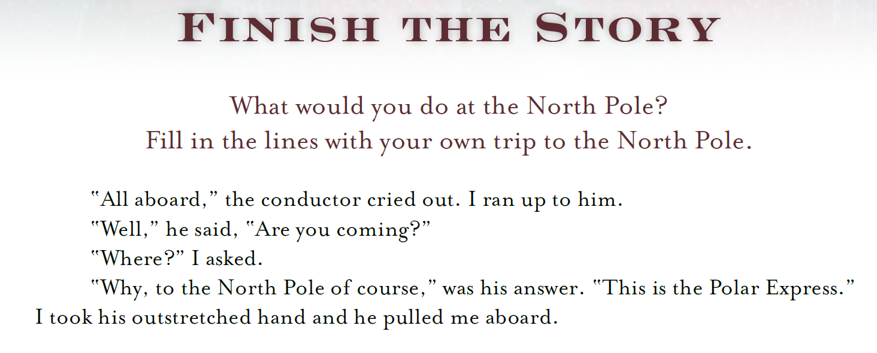A reproducible can be found on this website.  http://polarexpress.com/pdfs/Finish-the-Story-Activity.pdf |  |  | Day 8
STEM Activity: Students will create an electromagnetic train. |  | http://www.sylvanlearning.com/blog/index.php/after-school-activity-2/  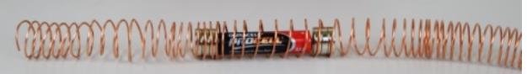or http://frugalfun4boys.com/2015/03/10/how-to-build-a-simple-electromagnetic-train/ | Day 9
Students will identify and demonstrate religious contexts.  Students will complete a Do You Believe exercise.  This activity demonstrates children's ability to believe in things they have not seen, to show how they can believe in an unseen God. |  | http://www.kidssundayschool.com/108/gradeschool/do-you-believe.php  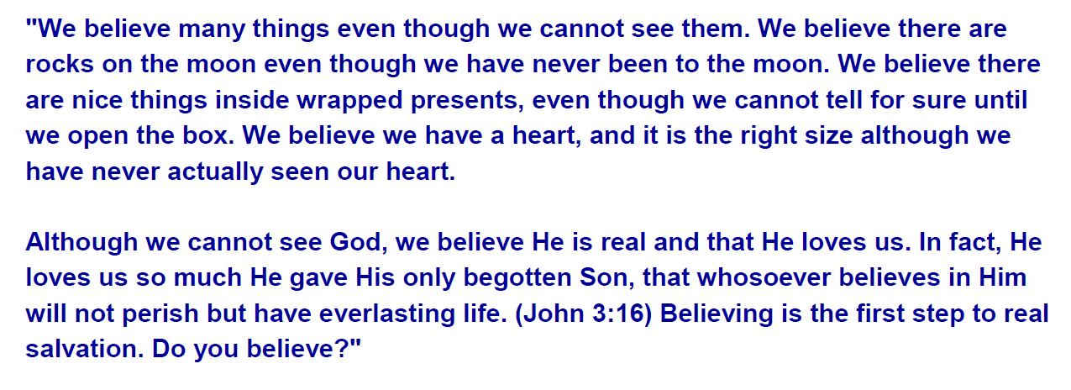  Bible: John 3:16 | Day 10
Students will watch the Polar Express movie. This activity will be used to compare activities via the book. |  | Polar Express movie | Day 11
Differentiated Instruction Opportunities/Overview: https://www.youtube.com/watch?v=Dfd8uoaSZ2M
Students can listen to the story on YouTube.
Students can choose the activities on the Polar Express website.
Students can create trains from toilet paper rolls, etc.

Cross Curricular Opportunities: Students will record responses and participate in literature circles. They will also be given opportunities to think-pair-share about the religious context within the Polar Express.
Common Core Checklist
Writing
*** | Paragraph
 | Essay (narratives, fairy tales, realistic fiction)
*** | Summary
 | Research
*** | Detailed answers (text supported)
 | Notes (note taking skills, outlines)
*** | Complete sentences
Reading
 | Informational text
 | Lexile
*** | Speaking
*** | Listening
 | Varied strategies and instructional methods
*** | Critical thinking in whole class discussion
*** | Student led activities
Technology
*** | Smartboard
*** | Computers
*** | iPads
 | Powerpoint, Elmo etc.
Differentiated Instruction
*** | Used multiple resources
 | Domain Vocabulary
*** | Cross-Curricular
*** | Collaborative engagement (meaningful feedback)
 | Higher level learning and teaching
Assessment
*** | Project based
 | ***
 | Portfolio
*** | Observation
 | Quiz
 | Technology based
 | Test
 | Student created test
 | Presentation
*** | Journal
*** | Think, pair, share
 | Summary
*** | Oral questioning
 | Analogy
 | Powerpoint, or movie maker
Authenticity
*** | Various activities
*** | Inquiry, research and evidence
 | Evidence of time management and planning
*** | Problem solving strategies
Summary of Unit:
We will be reading the Polar Express as a class and will watch the movie together. Discussions and activities will be centered on the topic of the religious correlations from both sources to our lives. The students will be communicating, journaling, and questioning on such topics/prompts. Students will inquire and be asked to think higher on such topics.

